TALMADGE COMMUNITY COUNCIL AGENDA
Tuesday, May 15, 2018 • 6:30-7:45 PM
Neighbor’s Home – 4760 Miracle Dr.
(Please enter from side door near Garage)

WELCOME, INTRODUCTION, and UPCOMING EVENTS – (10 min.)
- KenTal May 2018 Community Dinner with new SDPD Chief David Nisleit
- Food Truck Nights
- Annual Talmadge Neighborhood Garage Sale
- TMAD Monthly Meeting
- 4650 Aldine Drive final hearing and sentencing
- Monthly Volunteer Aldine and Fairmount Litter Picking
- KTPG Monthly Meeting

CRIME UPDATE – San Diego Police Department – CRO Terry Hoskins / Lt. Jud Campbell (15 min.)
- Recent crime activity and trends in and around Talmadge
- Car prowl activity and how to guard against it
- Talmadge Watch / Talmadge Patrol

GOVERNMENT UPDATES – (15 min.)
- Matt Yagyagan, representing City Councilmember Georgette Gómez
  - District 9 updates, including Traffic Circle diverter project status
- Toni Duran, representing California State Senate President pro Tempore Toni Atkins

SMART GROWTH IN AND AROUND TALMADGE – David Moty, Ken-Tal Planning Group (25 min.)
- Recent proposed Smart Growth legislation and potential impacts on Talmadge
- Possible ways to adapt to coming growth
- Possible steps for preserving Talmadge’s historic neighborhood character

NEIGHBOR OPEN FORUM – (10 min.)
- Opportunity to raise and discuss other neighborhood opportunities and concerns

NEXT MEETING – TUESDAY JULY 17, 6:30 PM
TALMADGE CRIME ACTIVITY – APRIL 14 to May 14, 2018
www.crimemapping.com
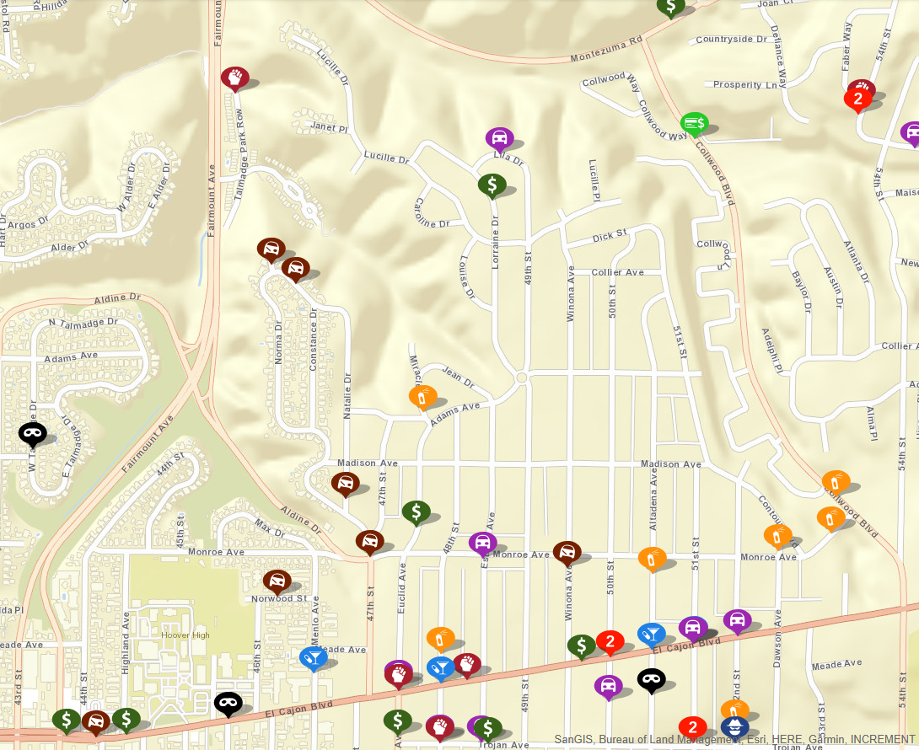
Assault
Vehicle Break-in
Burglary
Drugs & Alcohol
Fraud
Motor Vehicle Theft
Sex Crimes
Theft / Larceny
Vandalism

