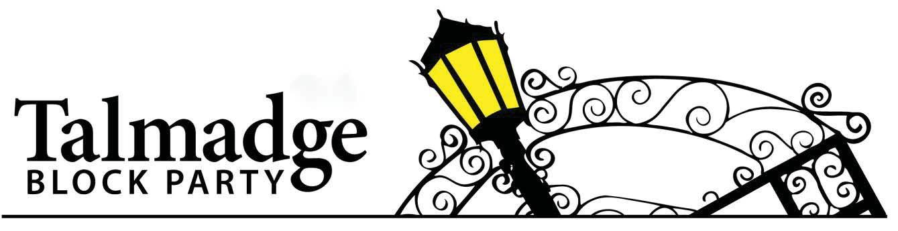
Saturday, October 5, 2024 • 2pm-6pm • Intersection of Euclid, Miracle and Adams Avenue

The Talmadge Block Party is an annual tradition in our neighborhood, bringing together residents from over 1,200 homes and across all ages for a day of fun, connection, and celebration. Hundreds of neighbors are joined by community groups for an annual celebration of everything that makes Talmadge the best place to live! This year, we are gearing up for our 23rd anniversary, and we are determined to make it the best one yet. That’s where you come in.
The Talmadge Block Party is a 501(c)(3) organization funded by the kindness of our fellow neighbors and community members, and run entirely by volunteers. After we host the Block Party, remaining proceeds are donated to local organizations dedicated to supporting our fellow community members. In the past, we have been proud to make significant donations to The Talmadge Patrol, Wilson Middle School, community trash pick-ups, Sharia’s Closet, the Copley Price YMCA Strong Girls, Choral Club of San Diego and many other worthy community causes.
Your contribution, no matter the size, can make a significant difference in the success of our event. It’s also tax deductible! Our Federal Tax ID# is 47-1166022. Whether it's a sponsorship, a monetary donation, a gift certificate, merchandise, or volunteer time, every bit helps in creating a memorable experience for everyone involved.

How to contribute

- Sponsorships
Feature your business prominently throughout our promotional materials and set up a booth during the block party to meet our attendees!
Platinum Sponsor | $1,500 donation
Includes a premium booth (10x20) with table(s), chairs, and pop-up shade tents provided. Display a banner with your business name across our most prominent location—the stage.
Diamond Sponsor I $1,000 donation
Includes a premium booth location (10x10) with table, chairs and a pop-up shade tent provided. Opportunity to display a banner with your business name in a prominent location. Display a banner in your booth if desired. Banner dimensions not to exceed 8 feet long and 2 feet wide. Stage thank you announcement
Gold Sponsor | $650 donation
Includes a standard booth (10x10) with table, chairs, and a pop-up shade tent provided. Display a banner in your booth if desired. Banner dimensions not to exceed 8 feet long and 2 feet wide.
Silver Sponsor | $350 donation
Includes a standard booth (10x10) with table and chairs provided. Display a banner in your booth if desired. Banner dimensions not to exceed 8 feet long and 2 feet wide. Shade tent not provided.
Bronze Sponsor: $100 donation
Named as a sponsor in event promotional materials Opportunity to display promotional at a shared table

- Raffle and Auction Donation
Contribute merchandise, products, or gift cards to be included in our raffle baskets. Exceptional items will be considered for Live Auction (value $500 or greater).
Note: Donors who contribute $25 or more in the form of merchandise, product, or gift certificates, will have their business promoted in a flyer distributed to the entire Talmadge community, a link on talmadgeblockparty.org and featured in the Ken-Tal News.
Interested in contributing?
If you would like to donate, please contact talmadgeblockparty@gmail.com and we’d be happy to pick up your donation.
- Checks should be made payable to: “Talmadge Block Party”
- Mailed donations can be sent to: Talmadge Block Party, P.O Box 600904 San Diego CA 92160-0904.

PLEASE COMPLETE AND RETURN TO TALMADGEBLOCKPARTY@GMAIL.COM
Select your sponsorship level and/or list your raffle and auction donation and contact information below

Business Name
Website
Mailing Address
Contact Name
Email Address
Phone Number
Event contact, if different

- Sponsorship (select one)
  - Platinum - $1,500
  - Diamond -$1,000
  - Gold - $650
  - Silver - $350
  - Bronze - $100
- Raffle Item (description and value of item(s) donated)
  - _______________________________________________________
Total Donation Amount: ______________

Checks should be made payable to: “Talmadge Block Party”
Mailed donations can be sent to: Talmadge Block Party, P.O Box 600904 San Diego CA 92160-0904. Please contact talmadgeblockparty@gmail.com and we’d be happy to pick up your donation.

